JobQuest Navigator – Week 4 Update Report

Maria Soto, Shruti Amit Vasanwala, Zhihuai Wang, Ishan Aakash Patel

Team 9
The Zombies of CAA

Seneca Polytechnic
Course Code: CAA900
David Chan

Project Summary

This week, the team made significant progress in both project planning and initial development activities. Key highlights include:

Selection of Job Market API:

Adzuna API was selected as the primary job market data source for our project.

Rationale: Adzuna offers a reliable free tier and comprehensive job listings, making it suitable for our needs.

API Integration Testing:

Successfully tested the Adzuna API for data extraction and integration with our project database.

Confirmed that collected job market information can be stored and retrieved efficiently.

- Microservices Development:
  - Epic 1:
    - Microservices architecture was elaborated, and initial designs were drafted.
    - Each team member was assigned specific microservices to evaluate and develop.

Weekly Meeting Minutes and Materials
Access the documents from our weekly meetings
00 Documents/0099 Final Documents/Reports/Meetings

Accomplishments

In Progress
- Microservices Development:
    - Ongoing evaluation and development of microservices for each epic.
- Project Documentation:
    - Continuous updating of project documentation on GitHub.

Challenges or Blockers
- Collaborative Work Structure:
    - Need to clearly define the structure for working across epics and tasks.

- Action Taken:
    - Sprints were defined based on epics and tasks to ensure all team members work in sync.

- Resource Limitations:
    - Limited access to certain APIs due to sign up or request requirements.

- Mitigation:
    - Focus on Adzuna API for initial development; other APIs to be explored as needed.

Visual Timeline of Progress
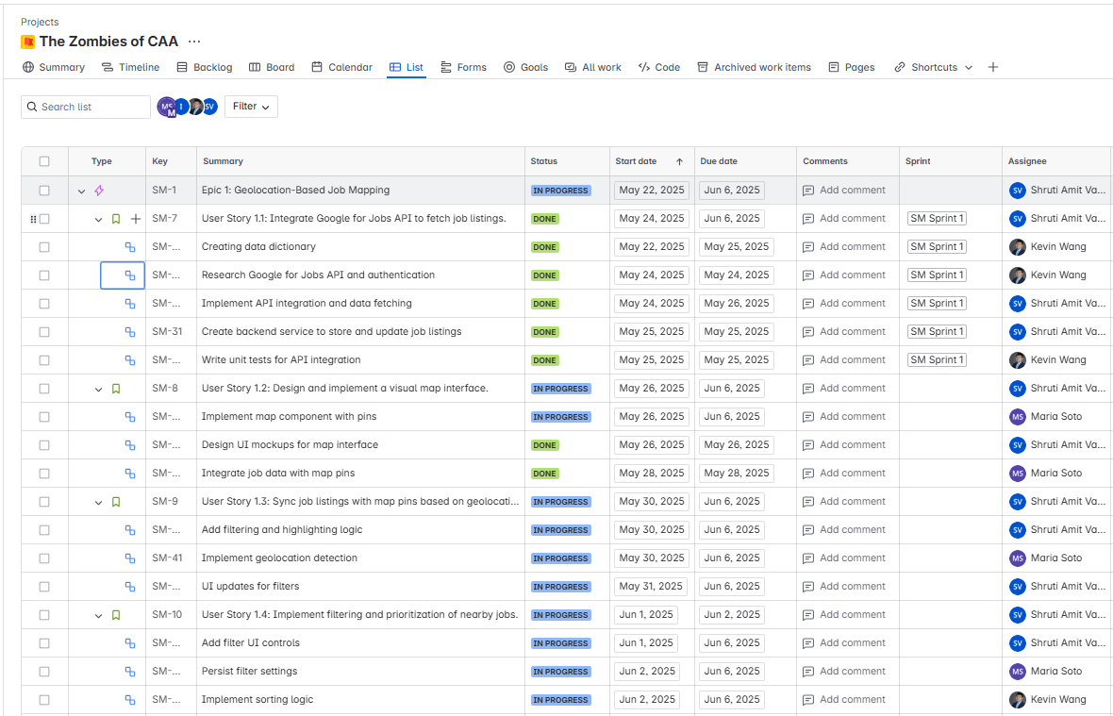

Plan for Next Week
- Microservices Development:
    - Finalize and assign microservices for each epic.
    - Each team member should work on their assigned microservices.

- Project Management:
    - Continue using GitHub for documentation and code management.
    - Hold regular check-ins to monitor progress and address any blockers.

- UI/UX Planning:
    - Begin working on Figma wireframes and UI design to visualize the application interface.

- User Stories:
    - User Story 1.2: Design and implement a visual map interface.
    - User Story 1.3: Sync job listings with map pins based on geolocation.
    - User Story 1.4: Implement filtering and prioritization of nearby jobs.
    - User Story 2.1: Build AI-driven resume version control system.

Sprint Status and Timeline
We are organizing the sprint to follow the good practices on project management.
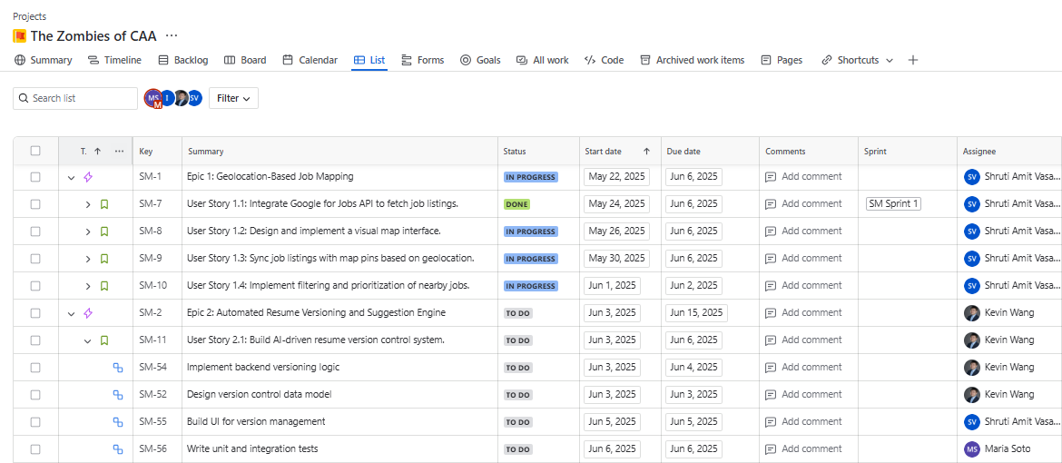

GitHub Documentation and Collaboration

- Repository Organization:
We have structured the GitHub repository by organizing folders and documentation to ensure all project information is easily accessible to team members.
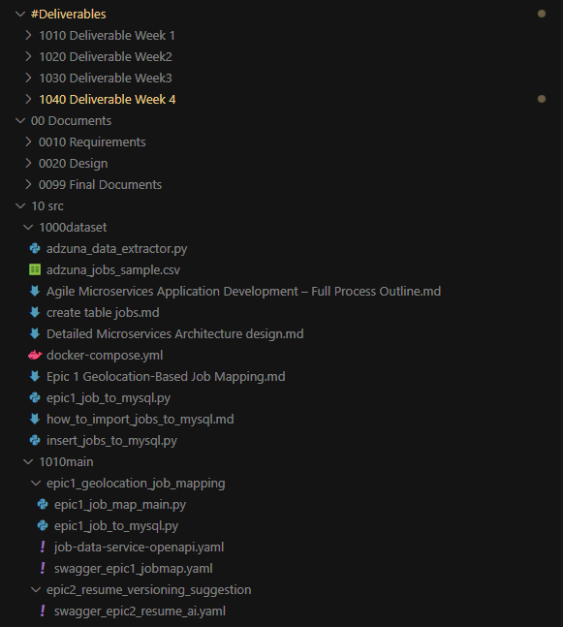
- Collaboration and Version Control:
Since last week, we have been actively using GitHub to track all project progress. Team members are now regularly creating and managing pull requests to facilitate code reviews and maintain a clear record of changes.
